The dataset has Census Canada 2016 for British Columbia data, the dataset almost 19million data point and 14 features. However, when transpose data, it will be 8385 data point and 2249 features. The data has 2247 features in the rows as a multi-dimensional data.

The dataset has features’ definition and its id in the rows, I will transpose the data and the features will be in the columns. You can find extra information in “98-401-X2016044_English_meta.txt” file which is in the dataset folder.

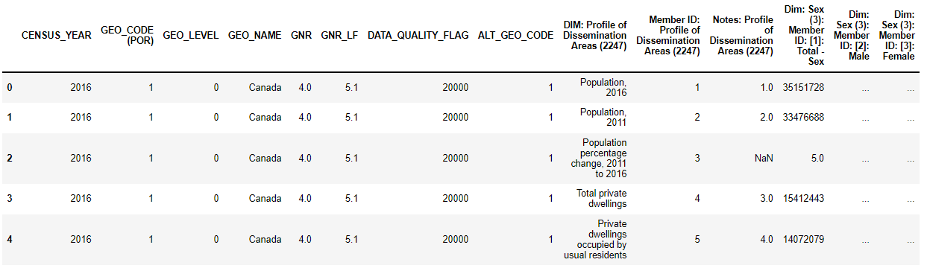

Figure 1: Before transpose

Figure 2: After transpose